


AWS Landing zone
IO Intelligence

www.trianz.com
TRIANZ CONFIDENTIAL

AWS Control Tower and Landing Zone Accelerator

AWS Control Tower is a service provided by Amazon Web Services (AWS) that simplifies the process of setting up and managing a secure, multi-account AWS environment. It offers an automated setup for a well-architected AWS environment that adheres to best practices, security standards, and compliance requirements.

Key features
- Landing Zone: It facilitates the management of multiple AWS accounts, enabling organizations to segregate workloads, applications, and environments while maintaining centralized governance and control.
- Security and Compliance: Control Tower implements AWS best practices for security and compliance, including identity and access management (IAM) policies, logging, monitoring, and enforcement of security guardrails.
- Automated Guardrails: Guardrails are predefined rules and policies that ensure compliance and security within the AWS environment. Control Tower provides a set of default guardrails, and users can also create custom guardrails tailored to their specific requirements.
- Account Vending: It streamlines the process of provisioning new AWS accounts, allowing administrators to quickly create and configure new accounts based on predefined templates and policies.
- Centralized Dashboard: Control Tower offers a centralized dashboard for administrators to monitor and manage the entire AWS environment. It provides visibility into account usage, compliance status, and security posture.
- Continuous Monitoring and Remediation: The service continuously monitors the AWS environment for compliance deviations and security vulnerabilities. It alerts administrators to any issues and provides recommendations for remediation.

AWS Control Tower and Landing zone Accelerator Lifecycle Workflow

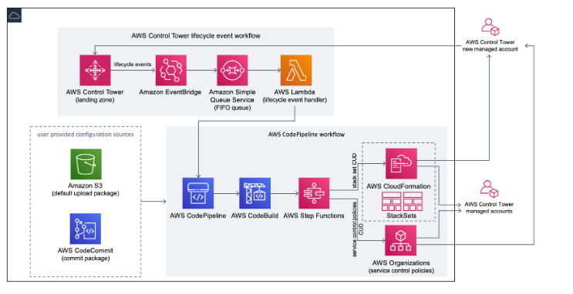
When a new account is created in AWS Control Tower, a lifecycle event can invoke the AWS CodePipeline workflow. You can customize the configuration package through this workflow, which consists of an Amazon EventBridge event rule, an Amazon Simple Queue Service (Amazon SQS) first-in first-out (FIFO) queue, and a AWS Lambda function.
When the Amazon EventBridge event rule detects a matching lifecycle event, it passes the event to the Amazon SQS FIFO queue, invokes the AWS Lambda function, and invokes the code pipeline to perform downstream deployment of stack sets and SCPs.
Prerequisites

1. AWS Control Tower is a region-specific service. The region must be selected before setting up the service. The region cannot be changed after provisioning the Landing Zone.

2. This service needs to be set up from the root account. It requires "Administrator Access" and "AWSControlTowerExecution" roles are required to set up this service.

3. The platform Landing Zone high level design must be ready before setting up the Landing Zone at the AWS Control Tower. The following regions will be enabled as allowed Regions.

Region Specific restrictions

At the AWS Control Tower, the following regions will be enabled as allowed Regions.

1. us-east-1 (North Virginia)
2. us-east-2 (Ohio)
3. us-west-2 (Oregon)

AWS Control Tower Landing Zone for IO Intelligence
The structure of a landing zone in AWS Control Tower is as follows:
- Root – The parent that contains all other OUs in your landing zone.
- Security OU – This OU contains the Log Archive and Audit accounts.
- Log Archive
- Audit
- Sandbox OU – The Sandbox OU is created to have an isolated test sandbox account for doing testing for infrastructure, application environment
- Workloads OU – The Workload OU will contain the workload accounts.
- Dojo-Dev
- Dojo-PreProd
- Dojo-Prod

- Infrastructure OU – OU used for shared Infrastructure services such as Networking, DNS, VPC Endpoints etc

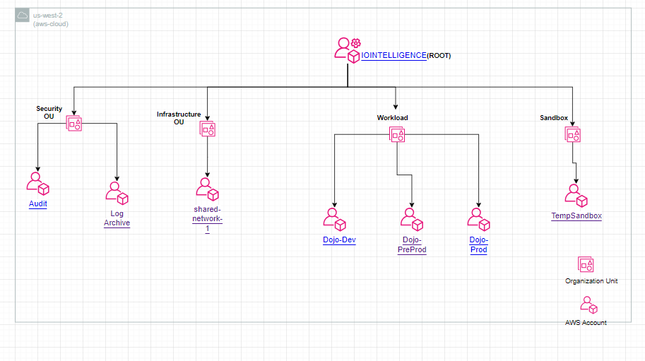
This Diagram Represents Control Tower Design for IO Intelligence

Control Tower Implementation

Pre-requisites for Setting up a Control Tower:
Amazon Web Services (AWS) Control Tower is a service designed to set up and govern a secure, multi-account AWS environment based on AWS best practices. Before setting up AWS Control Tower, it's essential to ensure you meet certain prerequisites. Here are the key prerequisites:
- AWS Account: You need an AWS account to get started. This account will be used as the management account for AWS Control Tower and also this will be used as a billing account.
- Permissions: You must have the necessary permission to set up AWS Control Tower. Specifically, you need administrative access to the AWS account that you plan to use as the management account.
- Networking: Ensure that you have network connectivity to AWS services from your network environment. This includes internet access for setting up AWS services and connectivity between the VPCs (Virtual Private Clouds) that Control Tower will create.

- Organizational Structure: If you plan to implement AWS Control Tower in an existing AWS organization, ensure that your organization is set up according to AWS best practices. If you're creating a new AWS organization, ensure that you understand how AWS Organizations work.
- Account Strategy: Define your multi-account strategy. AWS Control Tower is designed to help implement a multi-account AWS environment, so you should have a plan for how you want to organize your accounts. This may include designating accounts for different business units, applications, or environments (e.g., development, testing, production).

- IAM Users and Roles: Understand Identity and Access Management (IAM) concepts. Ensure that you have a good understanding of IAM users, groups, roles, and policies, as these are fundamental to controlling access to AWS resources.

- Compliance Requirements: Identify any compliance requirements that your organization needs to adhere to. AWS Control Tower provides guardrails based on AWS best practices, but you may need to customize these guardrails to meet specific compliance requirements.

- AWS Organizations: Understand how AWS Organizations work, especially if you're setting up AWS Control Tower within an existing organization. AWS Organizations helps you centrally manage and govern your AWS environment.

- Budget: Have a clear understanding of your budgeting and cost allocation requirements. AWS Control Tower provides tools for managing costs and budgets across multiple AWS accounts, so it's important to have a plan for how you want to allocate costs within your organization.

Implementation
Deploying AWS Control Tower involves several steps to set up a secure and well-governed multi-account AWS environment. Here's a detailed guide:
- Preparation:
  - Understand your organization's requirements, compliance standards, and security policies.
  - Define the organizational structure and account hierarchy you want to implement.
  - Create your shared account email addresses.
- Enable AWS Control Tower:
  - Sign in to your AWS Management Console with an AWS account that has the necessary permissions.
  - Open the AWS Control Tower console.
  - Follow the on-screen instructions to enable AWS Control Tower in your AWS Organization.
- Set up the Landing Zone:
  - AWS Control Tower will guide you through setting up the landing zone, which includes:
    - Defining your organizational units (OUs) to reflect your organizational structure.
    - Configuring identity and access management (IAM) policies for user and role management.
    - Setting up a centralized logging account for storing logs.
    - Configuring guardrails for enforcing security and compliance policies.
- Launch Control Tower:
  - After configuring the landing zone, initiate the launch process to provision the necessary AWS accounts and resources.
  - AWS Control Tower automatically creates core accounts such as a master account, log archive account, and audit account.
- Customization:
  - Customize AWS Control Tower settings based on your organization's specific requirements:
    - Configure additional guardrails or modify existing ones to align with your security policies.
    - Integrate AWS services and third-party tools for monitoring, logging, and security.
- User Provisioning:
  - Add users and groups to your AWS accounts using IAM.
  - Define IAM roles and policies to grant appropriate permissions to users and applications.
- Continuous Monitoring and Maintenance:
  - Regularly monitor your AWS environment using AWS Control Tower dashboards, AWS CloudTrail logs, and other monitoring tools.
  - Perform routine maintenance tasks such as updating guardrails, reviewing IAM policies, and addressing security findings.
- Governance and Compliance:
  - Use AWS Control Tower features like guardrails, centralized logging, and security automation to enforce governance and compliance standards.
  - Regularly review compliance reports and audit logs to ensure adherence to security policies and regulatory requirements.
- Optimization:
  - Continuously optimize your AWS environment for cost, performance, and security by leveraging AWS services and best practices.
  - Implement automation and DevOps practices to streamline operations and improve efficiency.

Service Control Policies

All Mandatory and custom SCP policy applied in respective OU.

Mandatory controls - AWS Prescriptive Guidance (amazon.com)

Landing Zone Accelerator Workflow
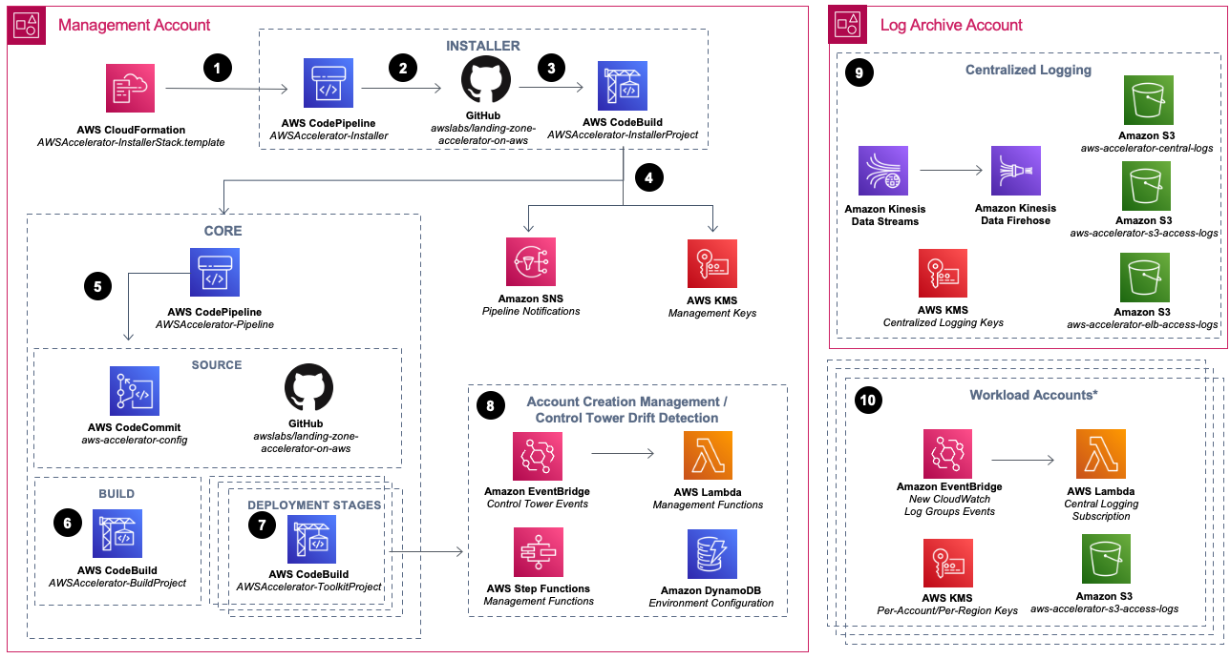
The Landing Zone Architecture is derived of the AWS Control Tower service and the Landing Zone Accelerator Solution (LZA). AWS Best practices will be used to build out this Landing zone Architecture, we will manage control Tower to manage as many solutions as possible. Any AWS Service that can NOT be managed by AWS Control Tower will be managed via the LZA Solution.

Landing Zone Accelerator Pipeline
The AWS CloudFormation template deploys two CodePipeline pipelines, an installer and the core deployment pipeline, along with associated dependencies. This solution uses CodeBuild to build and deploy a series of CDK-based CloudFormation stacks that are responsible for deploying supported resources in the multi-account, multi-Region environment.

AWSAccelerator-Pipeline will have the below stages:
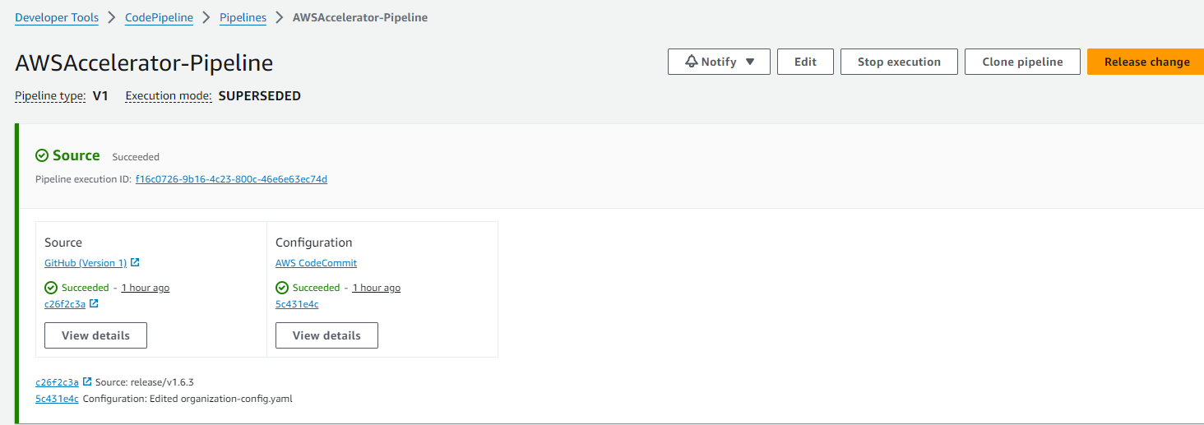
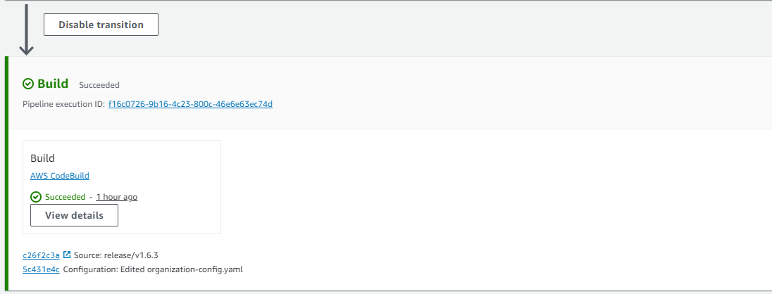
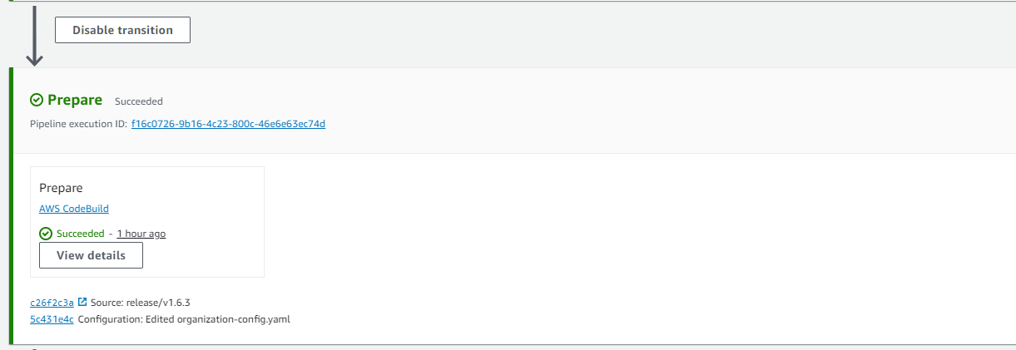
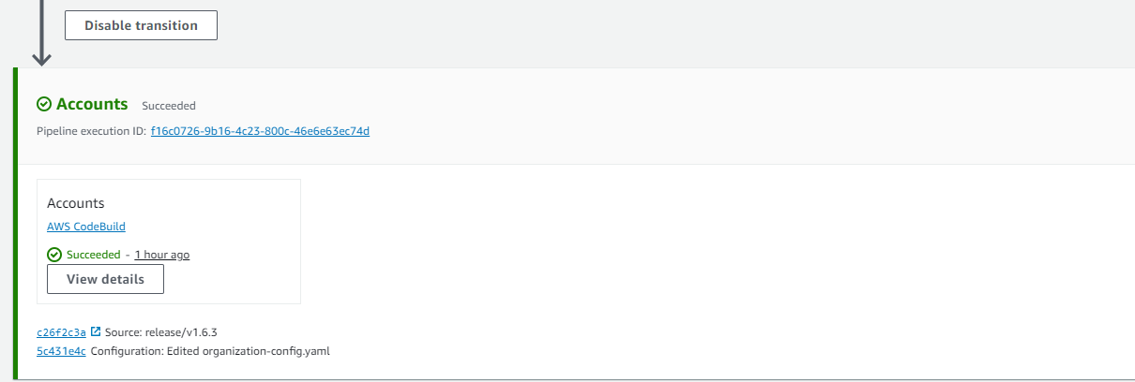
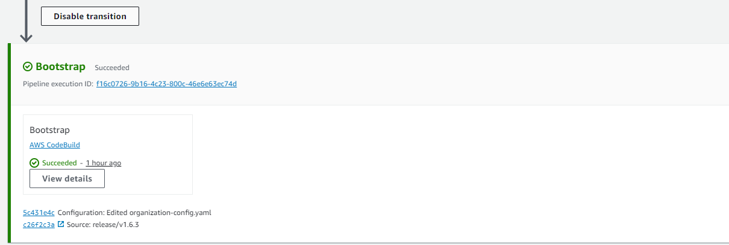
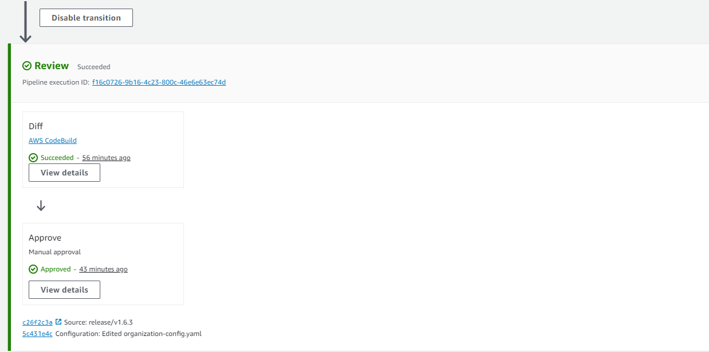
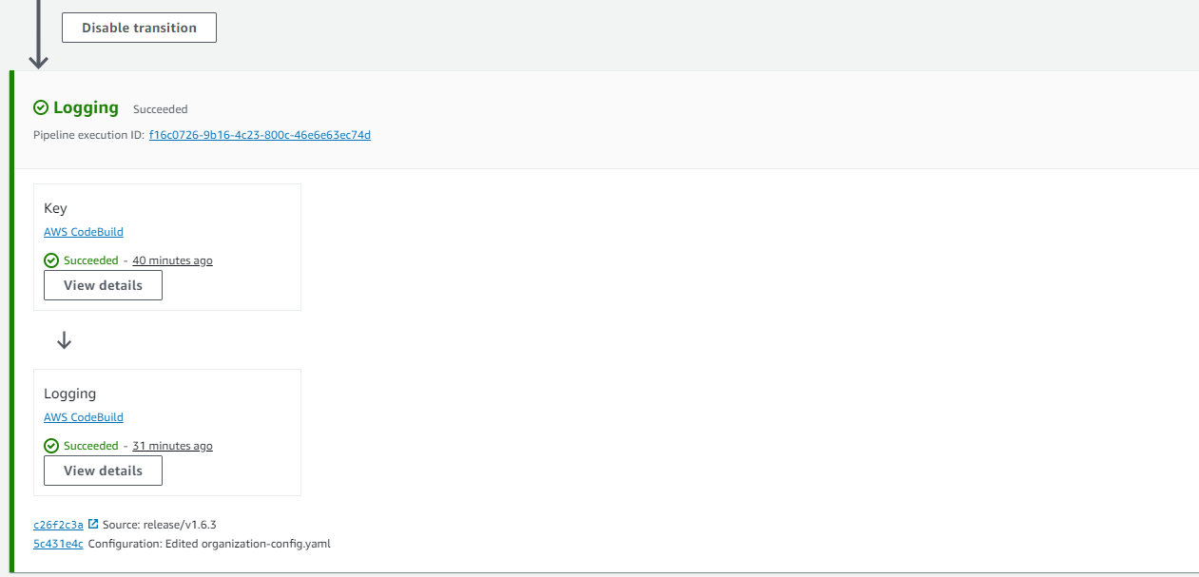
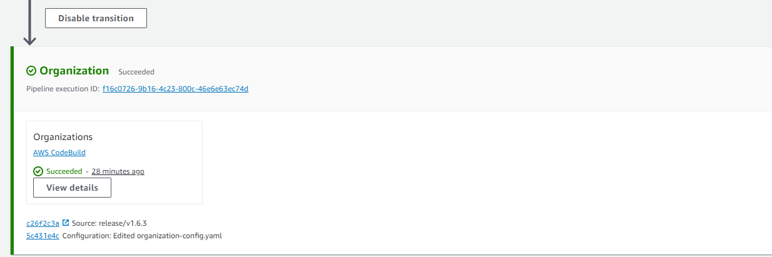
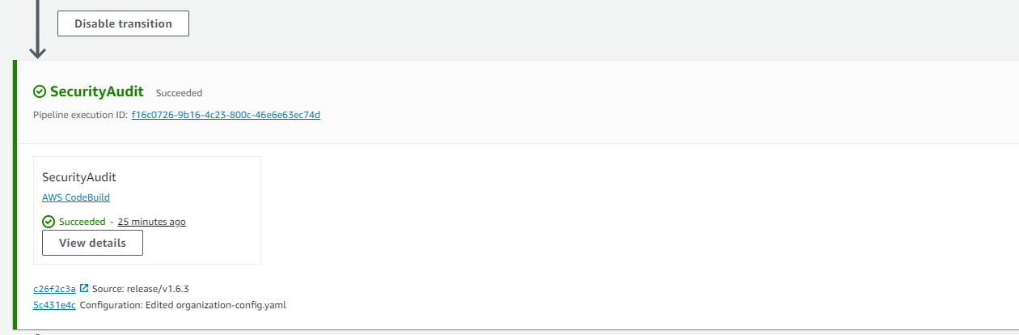
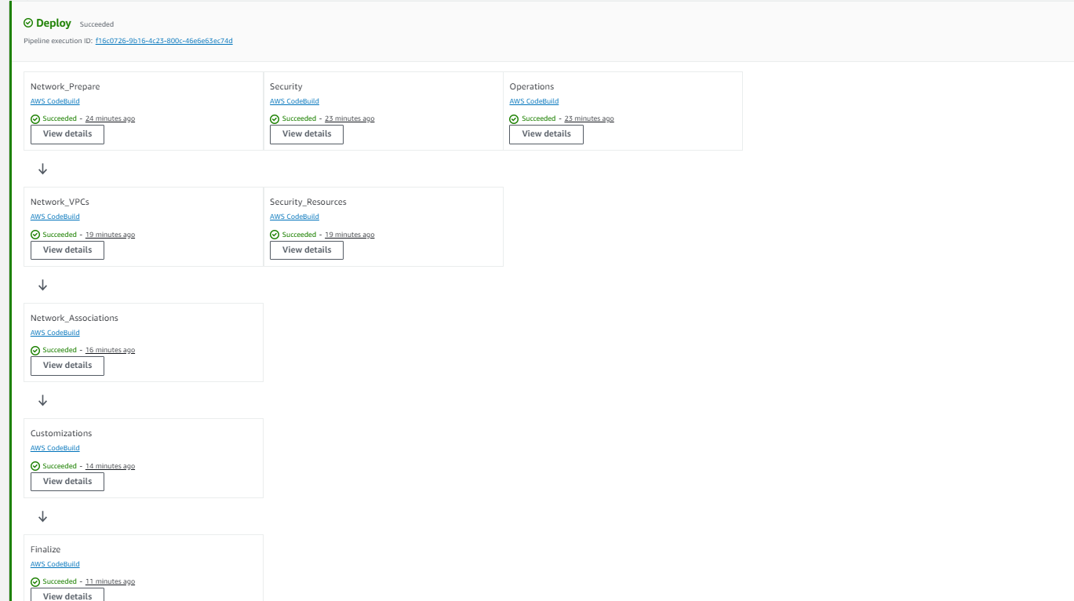

Landing Zone Accelerator Configuration files

Landing zone accelerator configuration files is stored in S3 bucket with prefix - aws-accelerator-config-, in the Management account

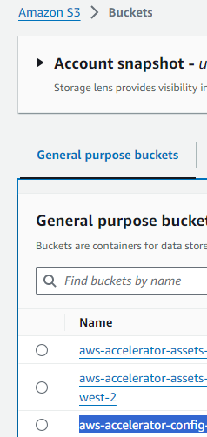

The configuration contains mainly below files, which is required to customize the configuration
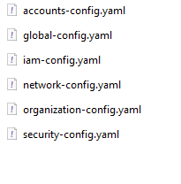
For customizing the configuration, download the zip file from S3 bucket, make the appropriate changes and upload to same location and run the Landing zone accelerator pipeline, to make the relevant customizations to landing zone.

Network Architecture
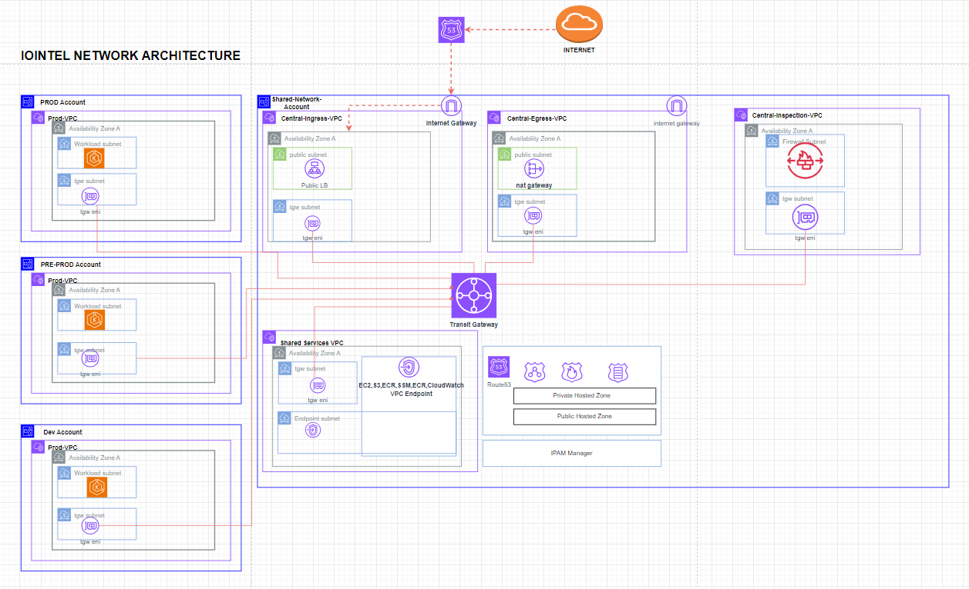

Inbound Networking

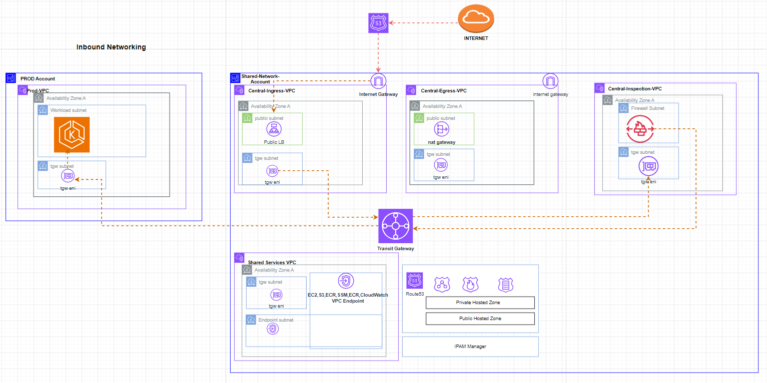

Outbound Networking

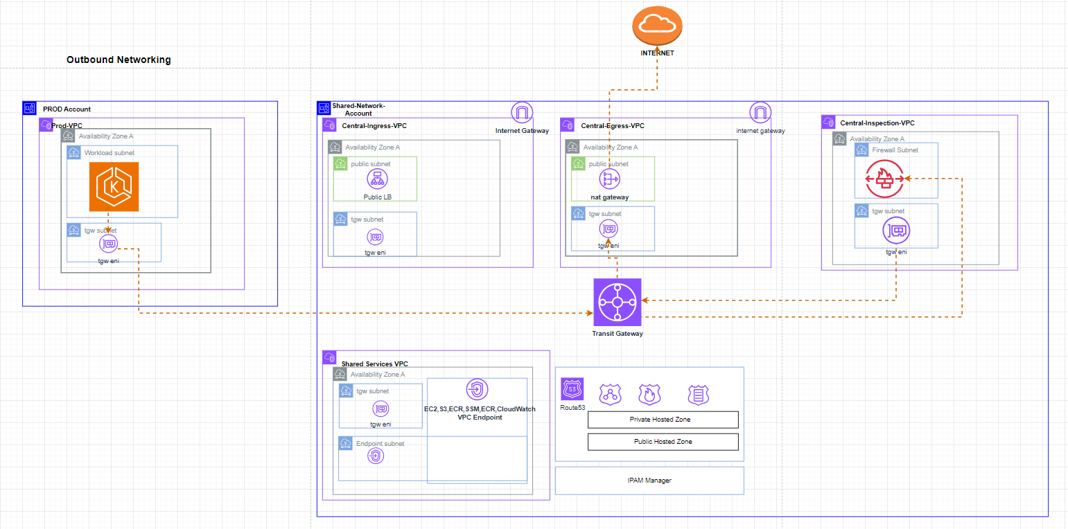

The Multi Account Architecture contains following Accounts and VPCs.
Shared Network Account –
Central Ingress VPC – This VPC acts as the centralized Ingress Network, where Public Ingress Load balancer is configured to serve the Inbound Application traffic. Internet Gateway is used here as the entry point to IOIntel AWS Network.
Central Egress VPC - This VPC acts as the centralized egress Network. All the Outbound public connectivity exit the AWS environment through the AWS NAT Gateway configured here.
Central Inspection VPC – Here the AWS Network firewall is configured, which will inspect all the network traffic
North-South – Network traffic entering and leaving the workload VPCs from/to the Public Internet
East-West – Network traffic between the different VPCs

Shared Service VPC – Centralized VPC Endpoint, DNS Route 53 is configured here. This is the centralized location through which the DNS queries, VPC endpoint connectivity is routed.
The entire Network configuration is customized using the LZA, network-config.yaml file.

Security and Compliance

We can benefit with enhanced security, centralized governance, cost management, scalability, and compliance adherence with AWS Landing zone solution.

AWS Landing zone Security services
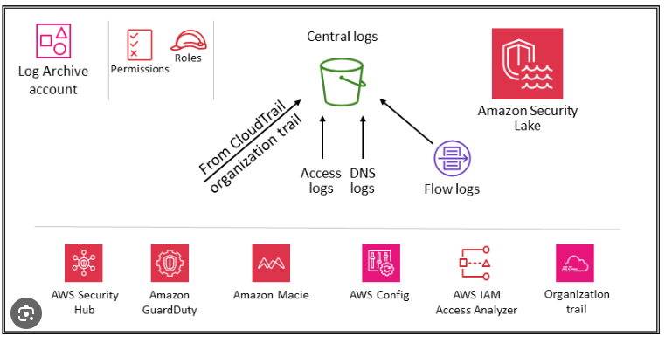

Security and Governance is achieved using various specific services like
Control tower Governance policies – Preventive and Detective Service Control Policies (SCP)
Centralized Identity and Access Management – Using AWS IAM Identity Center

AWS GuardDuty - Threat detection service that continuously monitors for malicious activity and unauthorized behaviour in your AWS accounts
AWS CloudTrail - Records AWS account activity, providing a comprehensive log of API calls and user actions.
Amazon CloudWatch - CloudWatch collects monitoring and operational data in the form of logs, metrics, and events, providing its users with an aggregated view of AWS resources, applications, and services that run on AWS.
CloudWatch can also be used to detect anomalous behavior in the environments, set warnings and alarms, visualize logs and metrics side by side, take automated actions, and troubleshoot issues.
AWS Security Hub - AWS Security Hub is a cloud security posture management service that provides a comprehensive view of your security state within AWS.
AWS Network Firewall – Inspects all East-West, North-South traffic…hence make it easier to manage and protect network traffic. Protects against unauthorized access and data exfiltration.

Audit Account is delegated as the Central Admin Account for managing the Security services for all the Accounts in the Organization.


Contact Information
sreeraj.murali@trianz.com

The content in this document is copyrighted; any unauthorized use – in part or full – may violate the copyright, trademark, and other laws. This document may not be modified, reproduced or publicly displayed, performed or distributed, or used for any public or commercial purposes. The Trianz name and its products are subject to trademark and copyright protections, regardless of how and where referenced.
Thank You

